Without Kafka how the connectivity and communication happens in Kafka .

Each component having multiple connection to each component which increases the connection count and makes more traffic.

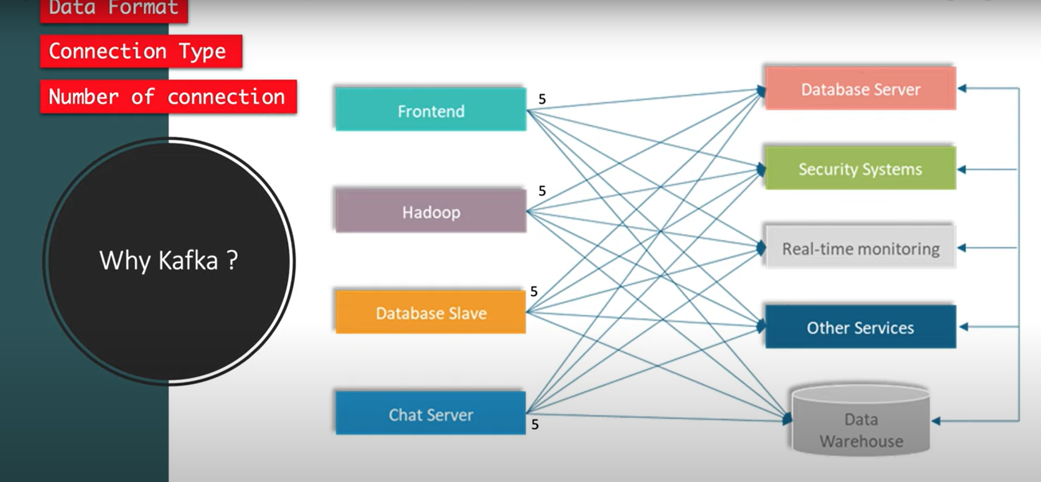

Why Kafka needed

It’s a middle man between the application connectivity and pick the request and sends to the destination with out creating much traffic and reduce the connection count.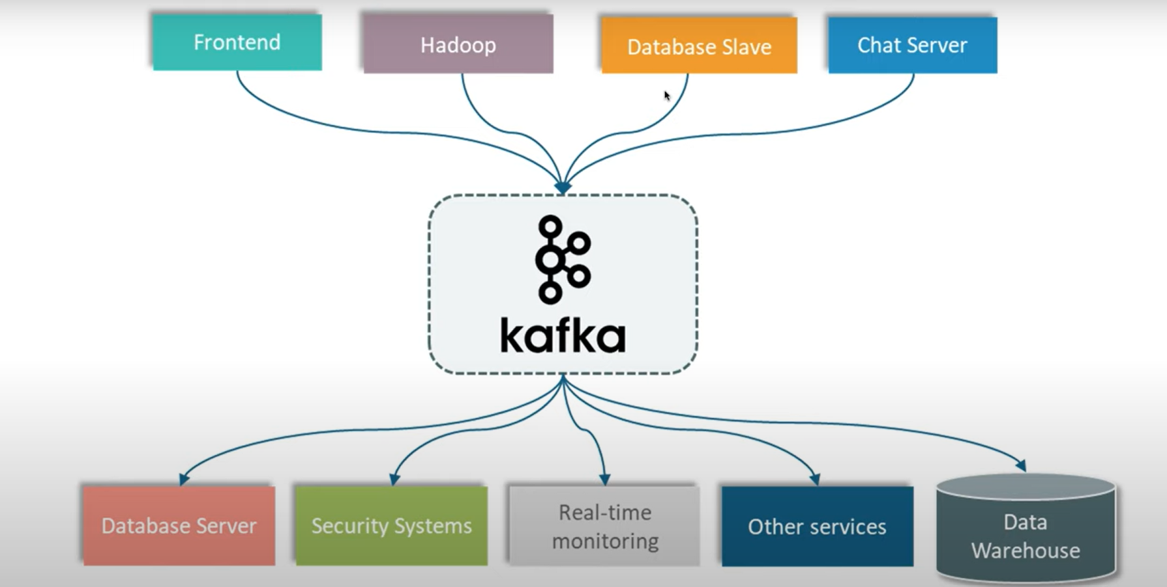

How does the Kafka works

Its work on pub/Sub model. Means publish and subscriber model .

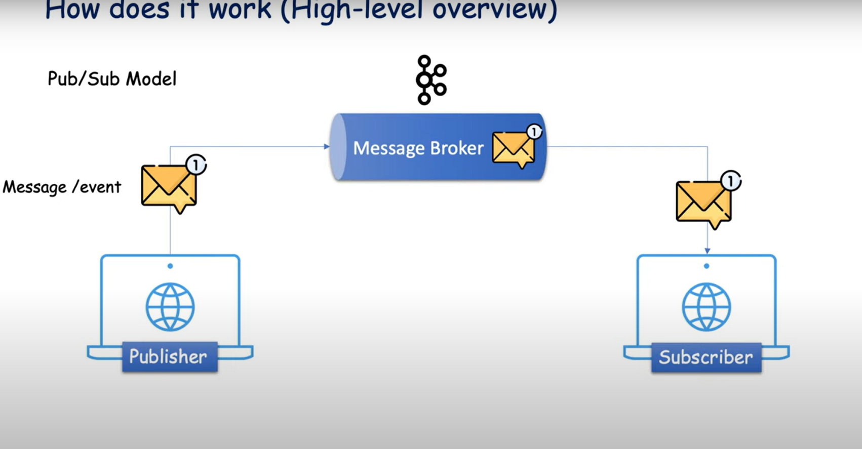

Kafka Architectures and Components:

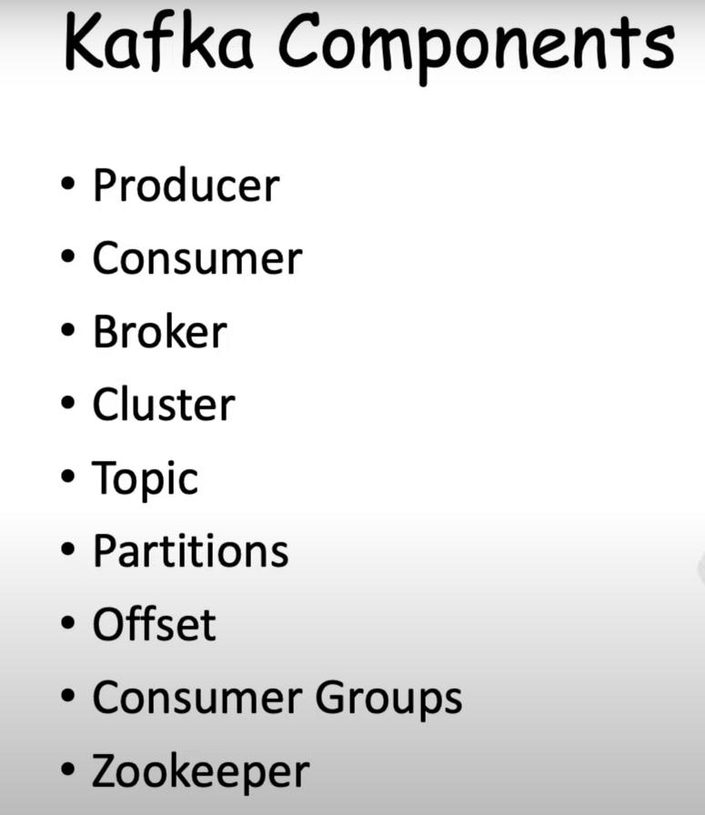

Producer Consumer and broker model

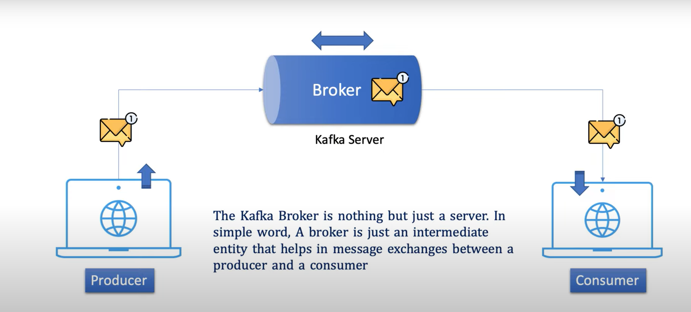

Cluster :

Its nothing but group of servers or machines . Kafka Cluster is a collection of multiples kafaka broker server .

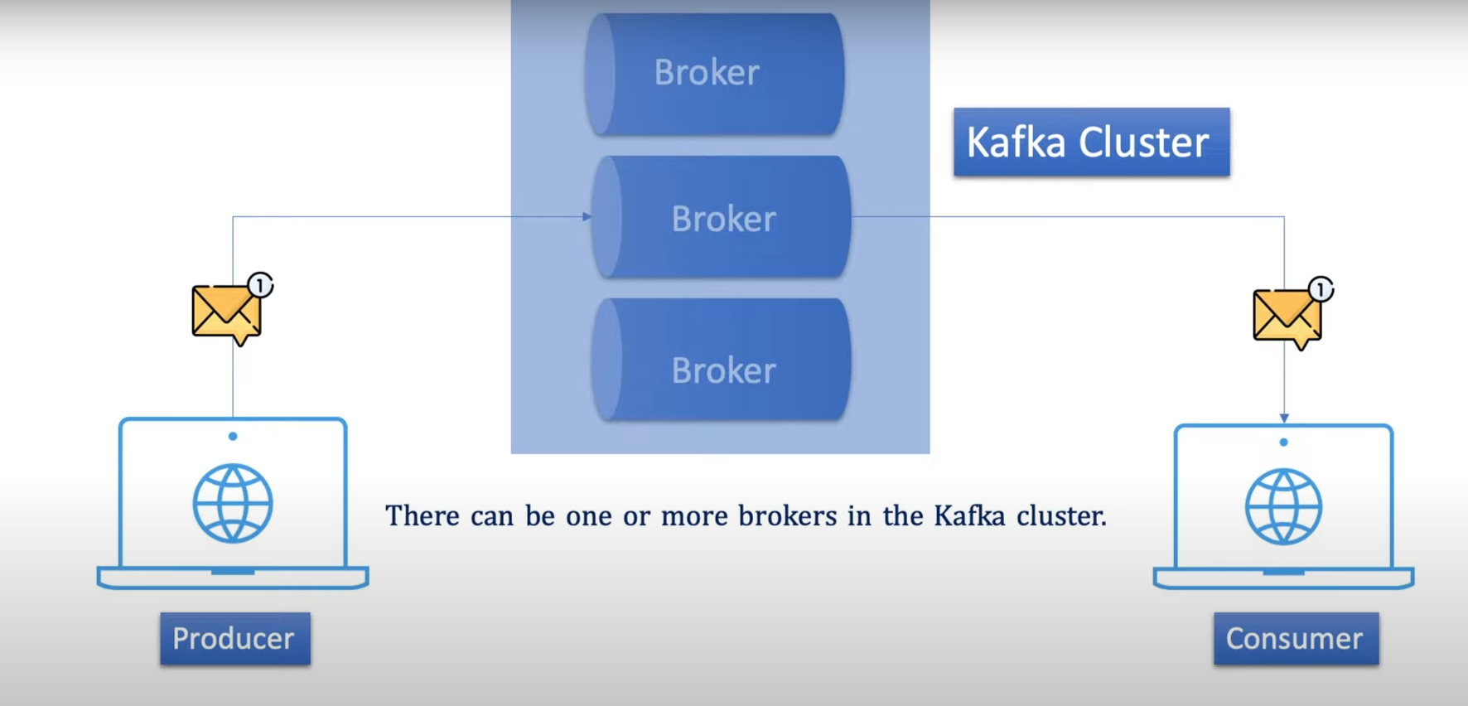

Topic:

Its categorized different type message or event based on categories there is different topics configured in broker . So its easier to consumer consume exact message from that topic by subscribing that topic and consumes particular message from the topic.

Topics act as a database table in kafka broker .

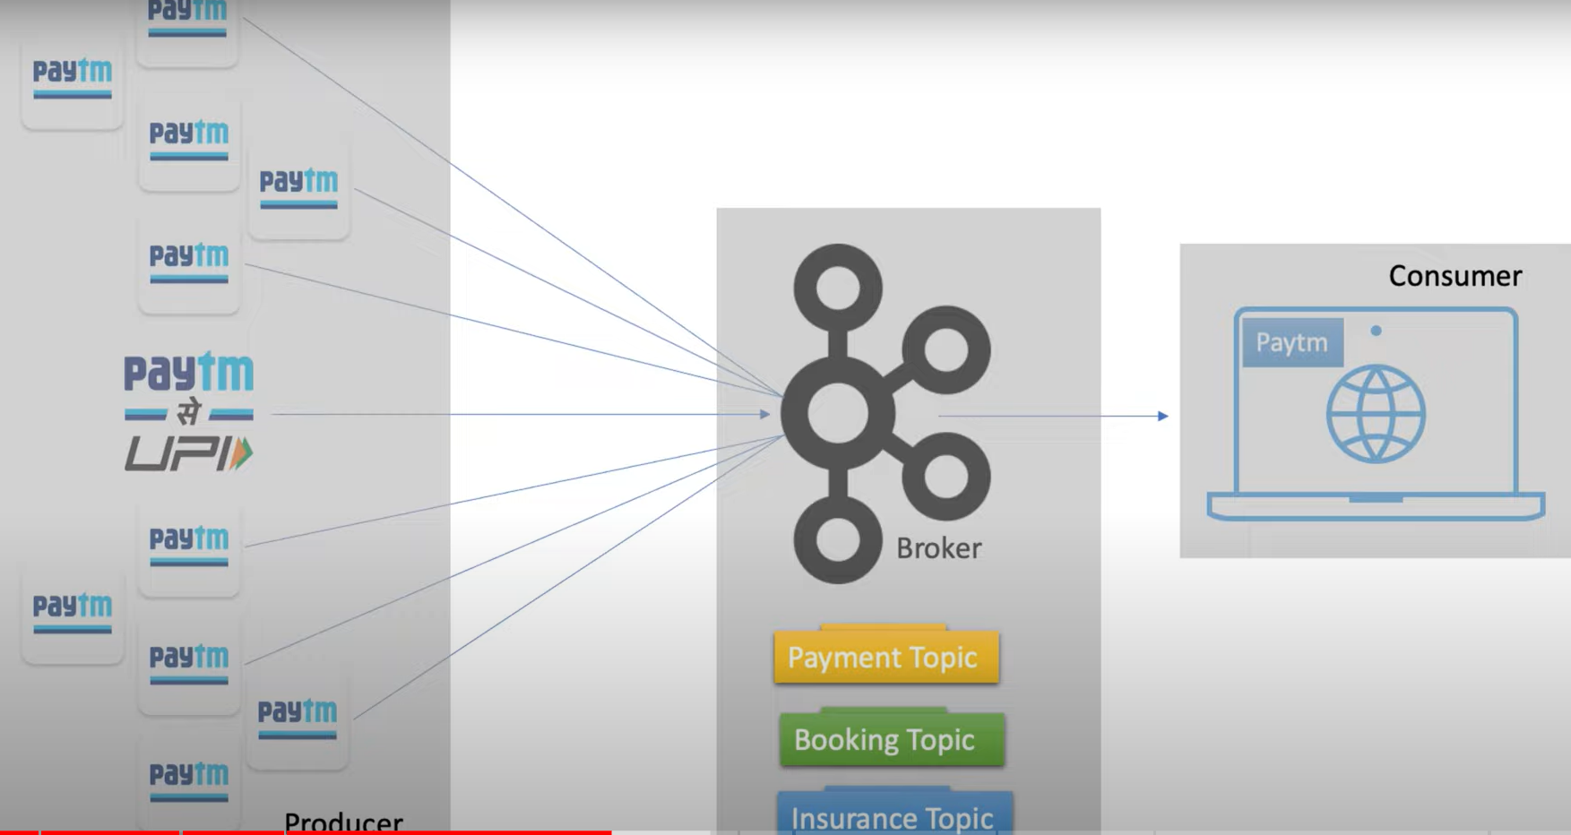

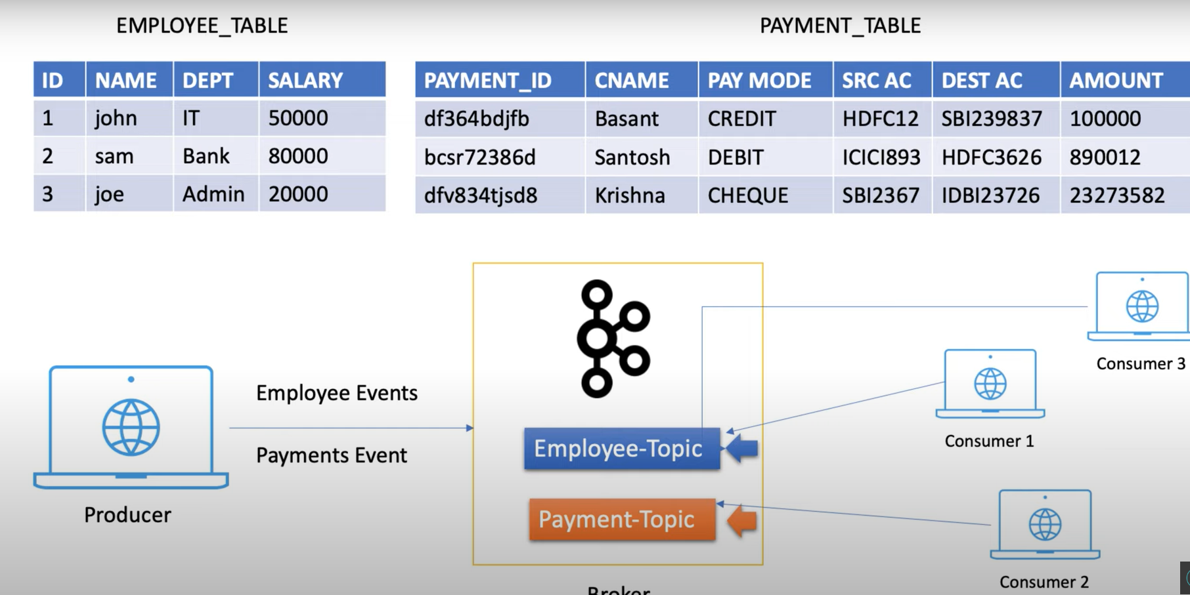

Partitions:

Suppose a producer sends millions or billions of message to th TOPIC . Will the topic able to handle those many messages . ?

Ther could be a lag in your system. Or it may be a storage challenge for kafka as well .

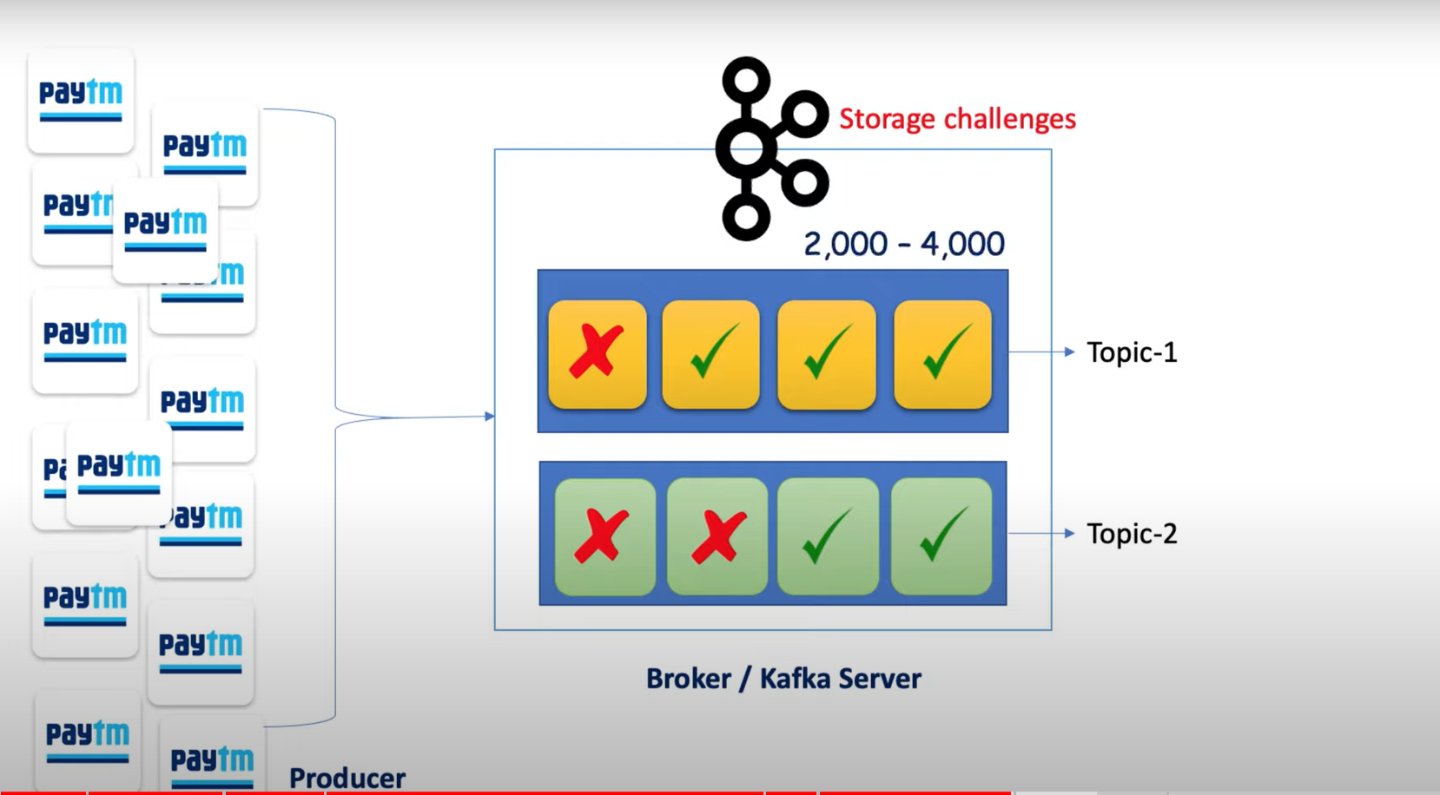

OffSets:

A Kafka server can multiples KAFKA server /broker .

Each Broker have multiple topics .

Each Topic can have multiple Partitions .

Here the thing to remember as soon as a message stored to the partition , there is a number assigned to the message and which is nothing but called offsets.

The main purpose of assigning offset to each message to keep track which message has already consumed by consumer .

Below is the diagram.

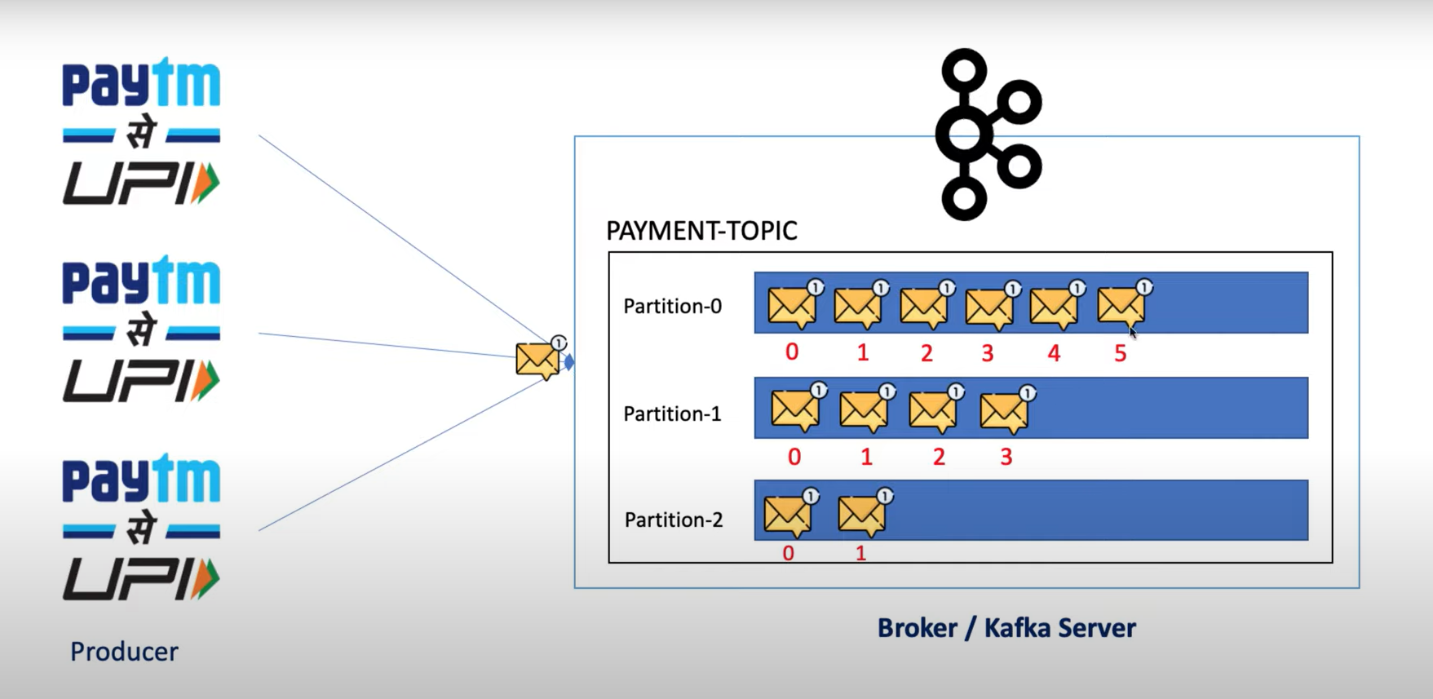

The key benift of Offset is just an example after consuming 4 messages the consumer is down now when the consumer will spin back . The offset number will help full to where to start consume the messages

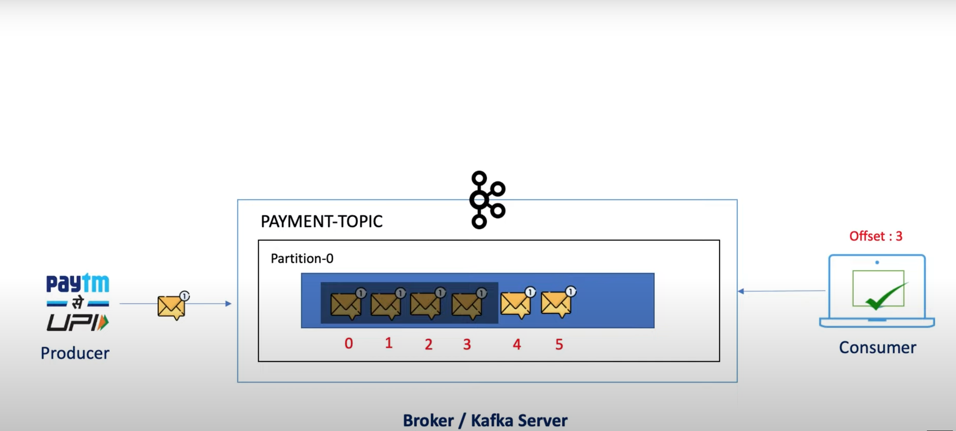

Consumer Group :

To achieve more throughput dived the consumer to multiple instances so its lead to high availability and the load of consuming message can distributed to multiple consumer .

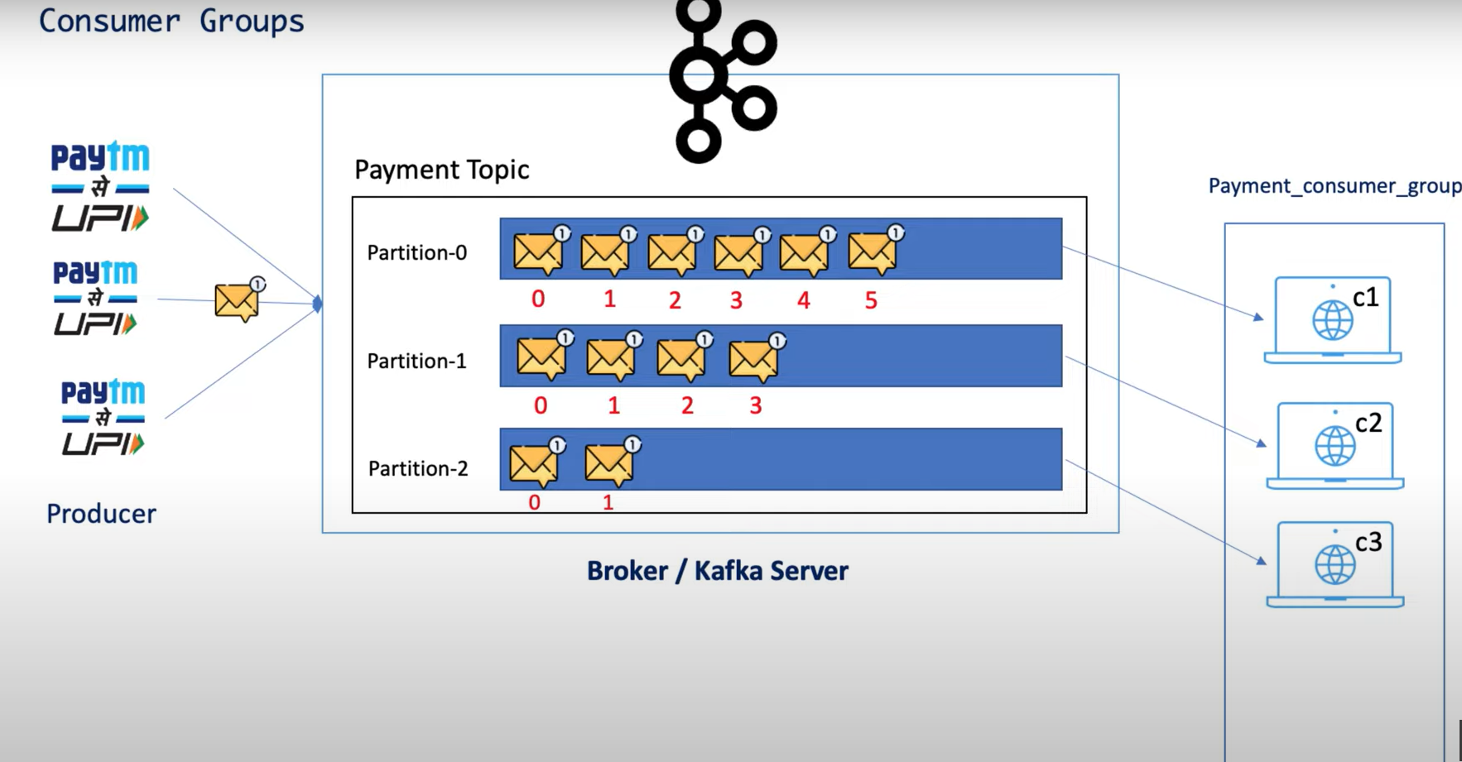

Zoo keeper:

Its keeps the coordination and tracks the status of kafka cluster nodes . Its also tracks the kafka topics partitions , offsets etc.

